Title
Author #1 ^{a,b}, Presenting Author ª, Author #3 ^{c}, Author #4 ^{a,b}….
ª Affiliation #1
^{b} Affiliation #2
^{c} Affiliation #1

* presenting_author@email.com

Abstracts are concise summaries of the overall research objectives, outlining the specific ideas and concepts to be presented, as well as expected results and practical implications. Please use Arial 10 pt font.
Authors: Underline and format the presenting author in bold text. For all authors, please list names with given name followed by the full surname.
Please limit your abstract to one single page. Do not change page layout.
A maximum of 1 image is permitted with your abstract (limited to one third of the page length).
References are optional but encouraged. Please limit them to the 5 most relevant citations at the end of the text, and cite them using numbers in square brackets.

Notification of acceptance will be sent to the presenting author's email address.
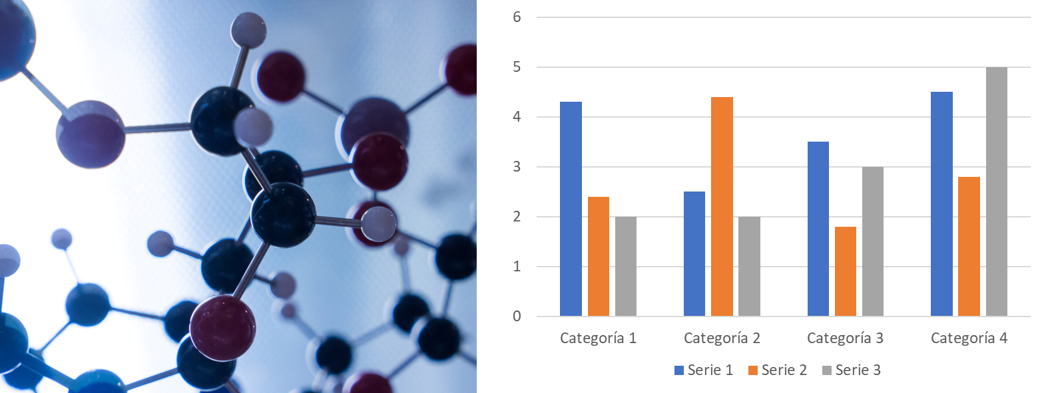
Figure - Description of the image
References
[1] Authors, Journal, vol, page (year).

(Preferred oral or poster contribution)

